**Exercise 6.4**

The plastics data set consists of the monthly sales (in thousands) of product A for a plastics manufacturer for five years.

1. Plot the time series of sales of product A. Can you identify seasonal fluctuations and/or a trend-cycle?

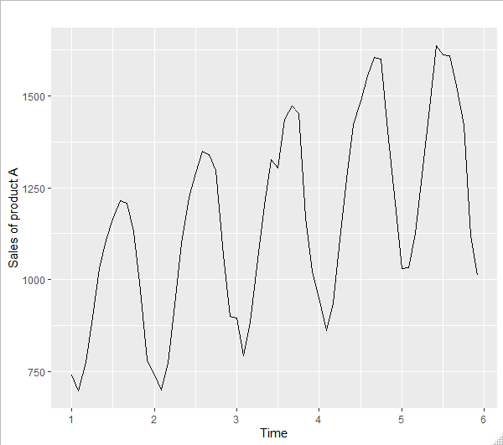

These are seasonal fluctuation and trends upward. Data look linear

1. Use a classical multiplicative decomposition to calculate the trend-cycle and seasonal indices.

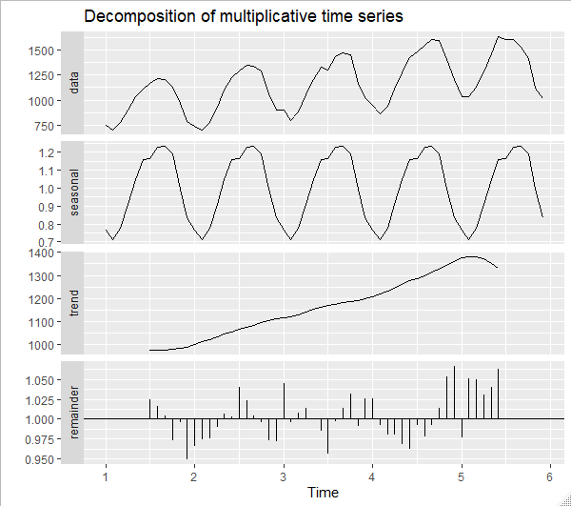

1. Do the results support the graphical interpretation from part a?

It does support the interpretation from part a. Looks like the decomposition shows more nonlinearity at the beginning and end of the graph

1. Compute and plot the seasonally adjusted data.

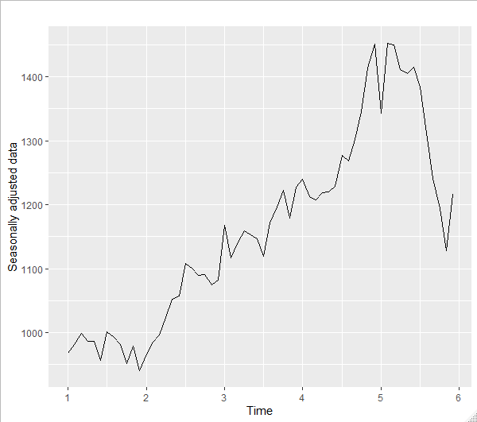

1. Change one observation to be an outlier (e.g., add 500 to one observation), and recompute the seasonally adjusted data. What is the effect of the outlier?

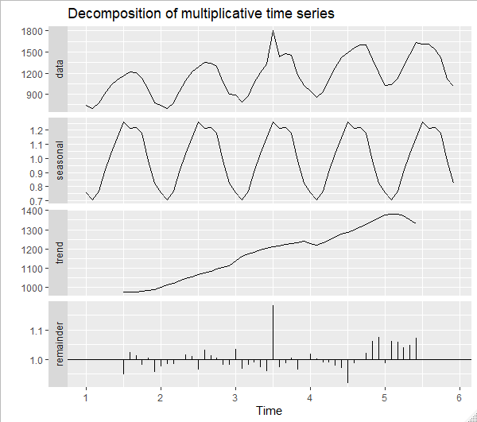

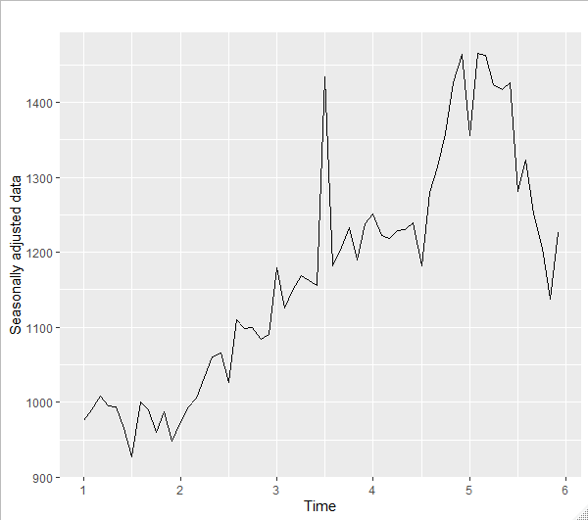

The effect of the outlier is not much of a difference, maybe 200-300

1. Does it make any difference if the outlier is near the end rather than in the middle of the time series?

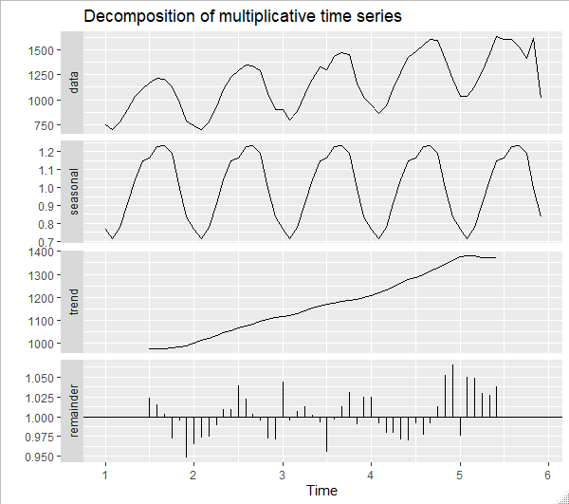

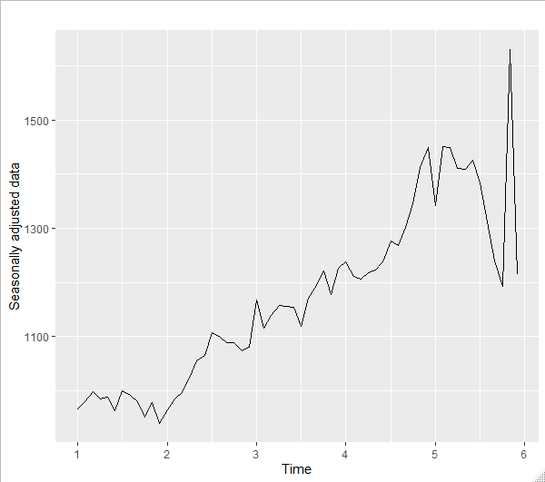

The outlier is affecting the data much more when it is on the end of the data as compared to the middle. See huge spike at month 6.

**Exercise 6.4**

1. Write about 3–5 sentences describing the results of the decomposition. Pay particular attention to the scales of the graphs in making your interpretation.

* The plot shows an upward trend with some seasonal fluctuations most likely due to pre-holiday hiring and post-holiday workforce reduction
* There looks to be a larger than normal reduction in workforce around 1991/1992, potentially due to a large company lay-off or maybe a strike
* December workforce hiring seems to be increasing over the years
* There is a larger decrease in workforce in June, July, or August

1. Is the recession of 1991/1992 visible in the estimated components?

Yes the recession is visible in the remainder component and slightly in the data component, but not much elsewhere